

Low Level Design Document

FOR

New Okhla Industrial Development Authority

This document provides details of the technical architecture, user interface & system design at a low level.

ABSTRACT
Document Title: | Low level Design Document
Project: | New Okhla Industrial Development Authority
Author : | Sudhir Mangla, for North Shore Technologies.
Filename: | NOIDA_Low Level Design.pdf
Version: | 1.0
Status: | Dhananjay Kumar
Date: | 04/25/2016

[This document contains a detailed description of the high level design and technical architecture of the project/solution North Shore Technologies . is building for NOIDA Logistics & Fine Art Services.]

Privileged Business Information - Do Not Release.
This document contains Trade Secrets of North Shore Technologies. With the receipt of this document, the receiver agrees to keep strictly confidential, all Trade Secrets of North Shore Technologies contained herein.
Copying this document, giving it to others, and the use or communication of the contents thereof, is forbidden without express authority. Offenders are liable to the payment of damages. All rights are reserved especially in the event of the grant of a patent or the registration of a utility model or design.
© North Shore Technologies. 2016.

Revision History

Version | Date | Notes | Prepared By | Review By | Approved By
0.1 |  | Initial Draft | Sudhir | Dhananjay | Pradeep

Contents

1. Introduction 6
1.1 Purpose 6
1.2 Objective 7
1.3 Technology Overview 7
1.4 System Overview 8
1.6 Definitions and Acronyms 8
2. Design Considerations 9
2.1 Technology Stack 9
2.2 Assumptions 11
3. High Level System Design and Architecture 12
3.1 System Architecture Overview 12
3.2 System Architecture: Layers & Subsystems 12
3.2.1 Presentation Layer: 14
3.2.2 Service Layer: 15
3.2.3 Repository Layer: 16
3.2.4 Data Layer: 17
4. Low Level System Design 18
4.1 Authentication and Authorization 18
4.1.1 Login/Logout Process: 18
4.1.1.1 Use Case Model 19
4.1.1.1.1 User Login and forgot password Sequence Diagram: 19
4.1.2 User Management By Super Administrator: 21
4.1.2.1 Use Case Model 21
4.1.2.1.1 Web/Presentation Layer 22
4.1.2.1.2 Business and Repository Layer 22
4.1.2.2 Sequence Diagram 24
4.1.2.2.1 Admin Role Management Sequence Diagram: 24
4.1.2.2.2 User Management Sequence Diagram (Super admin): 25
4.1.3 User Management By Administrator: 26
4.1.3.1.1 Business Layer 27
4.1.3.1.2 Role Management Sequence Diagram (Admin): 29
4.1.3.1.3 Map User Sequence Diagram (Admin): 30
4.1.4 Menu Mapping 31
4.1.4.1.1 Business Layer 31
4.1.4.2 Sequence Diagram 32
4.1.4.2.1 Menu Security Sequence Diagram: 32
4.2 Master data management 33
4.2.1 Manage Scheme 33
4.2.1.1.1 Business Layer 34
4.2.2 Manage Property 35
4.2.2.1.1 Business Layer 36
4.2.3 Manage Notification 37
4.2.3.1.1 Business Layer 38
4.2.4 Manage Refund 39
4.2.4.1.1 Business Layer 40
5. Database Design 42
6. Appendix 42

Introduction

1.1 Purpose

NOIDA Constituted under the U.P. Industrial Area Development Act, 1976, has now emerged as a planned, integrated, modern Industrial City, well connect to Delhi through a network of roads, national highways and the ultra - modern DND flyover, offering inter - road linkages to all parts of the country. The growth rate of Noida has been remarkable since its inception, creating a need for an optimized business process to serve the citizens, and different establishments like industrial, commercial, institutional etc. In current working system within NOIDA, data management is primarily in physical form. A complete lack of interfaces at authority level to communicate makes it harder to conduct activities. An optimized business process is required across the different entities/departments of NOIDA to attain the desired level of efficacy and ensure better services to the citizens/consumers.
North Shore Technologies is developing an Integrated Property Management System that will allow automation of whole business process starting from allocation of industrial property to Lease deed execution; from Lease Deed to functional and various other processes including Transfers, Mortgage, and Substitution etc. This system would allow common work processes to be performed efficiently by all departments in NOIDA.
The overall purpose of this project is to build up an Integrated Property Management system. This system would allow automation of whole business process starting from allocation of industrial property to Lease deed execution; from Lease Deed to functional and various other processes including Transfers, Mortgage, and Substitution etc. This system would further facilitates access on web browser and allow adoption of a comprehensive approach towards gaining the efficiency. It would share the relevant information across various departments which will help in making operational as well as strategical decisions.
The key features of the system includes the automation of the business process involved right from allocation to the lease rent calculation and payment. The list of functional requirement for managing the industrial properties at NOIDA are as follow:
- Ability to add or upload list of allotted of Properties.
- Ability to manage the customer data.
- Ability to create payment schedule.
- Ability to calculate the payment at any point of time.
- Ability to auto generate various type of letter like allotment, possession, functional letter etc.
- Ability to send auto reminder to customer for any outstanding payment.
- Ability to see list of all relevant documents.
- Ability to connect with payment and receipt system for reconciliation at the end of every period.
- Ability to change the basic details of applicant.
- Ability to send an instruction to accounting system for payment or initiating the refunds.
- Ability to add any details to the properties.
- Ability to see various reports based on defined parameters.
- Ability to send notifications to customers using SMS/email.
- Ability to provide an interface which can be accessed by authorized Noida official anywhere and anytime.

The scope of this document is limited to providing a technical approach to meet all requirements and predefine the architectural guidelines that would be followed across the life cycle of the project development.

1.2 Objective
This document is intended to provide a low level overview of the design considerations for creating this system for NOIDA in order to meet all requirements as provided by them. And to:
- Identify and describe the software architecture for the system.
- Provide high-level approaches to various technical challenges.
- Provide a guide for future development efforts, such as detailed design and coding.

1.3 Technology Overview
This document describes the architectural guidelines for the various pages and modules of the desired site. It also describes the user authentication & access as well as the logical view of the system.
The system would be ASP.NET MVC 5.0 based and will have Oracle 10g as the backend database.
It would be a custom web forms based web application combining coded elements such as Partial Views, ASP.NET MVC web forms/pages and custom content such as master pages, layout pages, graphic files and other reporting based web pages etc.
This document provides details of the user interface & system design at a high level other than the technical architecture of the system.

1.4 System Overview
The NOIDA system will consist of four major components. These are:
- Client UI/System – i.e. the web browser, to present user interface of NOIDA application. Using this UI, the NOIDA User will interact with the system and perform input/output operations on the system.
- Middle Tier –ASP.NET MVC application which provides the majority of the business logic and data processing.
- Database(s) /Persistence – Primarily Oracle 10g, including Authentication and Transactional elements.

The project would be divided into the following logical modules:
- Authentication and Authorization – This module would cover the following business functions:
- Log in/log out process
- User Management
- Create new user
- Edit user
- Delete user
- Deactivate user
- Activate user
- Create User level
- Deactivate User Level
- Activate User Level
- Menu mapping

1.6 Definitions and Acronyms
API | Application Program Interface
BO | Business Object
GUI | Graphical User Interface
HTML | Hypertext Markup Language
HTTP | Hypertext Transfer Protocol
XML | Extensible Markup Language
SP | Stored Procedure
DAL | Data Access Layer
BAL | Business Logic Layer

Design Considerations
This section describes issues that need to be addressed or resolved prior to or while completing the design as well as issues that may influence the design process.

Technology Stack
Name | Description
ASP.NET MVC 5.0 | ASP.NET MVC 5.0 which is a part of the .NET Framework is a unified Web development model that includes the services necessary for building enterprise-class Web applications. It is a powerful platform for building dynamic web applications that provides a tremendous amount of flexibility and power for building just about any kind of web application from small, personal websites through to large, enterprise-class web applications.
Model View Controller(MVC) | How do you modularize the user interface functionality of a Web application so that you can easily modify the individual parts? The Model-View-Controller (MVC) pattern separates the modeling of the domain, the presentation, and the actions based on user input into three separate classes:  Model: The model manages the behavior and data of the application domain, responds to requests for information about its state (usually from the view), and responds to instructions to change state (usually from the controller).  View: The view manages the display of information.  Controller: The controller interprets the mouse and keyboard inputs from the user, informing the model and/or the view to change as appropriate
JSON(JavaScript Object Notation) | JSON is an abbreviation for JavaScript Object Notation and is a messaging or lightweight data interchange format that is optimized for communication. It is structured as a collection of name/value pairs in an ordered list of values. It is text based and position independent. It provides many of the attributes of XML yet provides a superior structure for exchanging data on the network. Among its advantages are its simplicity, interoperability and openness. It is not extensible like XML but it was not designed to be so. It is human readable, information rich and it is simple and standard. It provides the ability to self-describe the data it contains and supports Unicode so that it can be used in international applications. It is becoming the messaging standard of choice. George will be implemented utilizing a JSON architecture
.Net Framework 4.5 | The .NET Framework is an integral Windows component that supports building and running the next generation of applications and Web services. The key components of the .NET Framework are the common language runtime (CLR) and the .NET Framework class library, which includes ADO.NET and ASP.NET MVC. The .NET framework also consists of technologies such as Windows Workflow Foundation (WF), Windows Communication Foundation (WCF), WEB API, WPF etc.
Oracle 10g | The Oracle database allows the creation of web services. Writing Stored Procedure Web Services involves creating and installing a PL/SQL package or an embedded Java package on an Oracle database server that is available as a data source to Oracle Application Server and generating a Java class that includes one or more methods to access the Stored Procedure
Microsoft Visual Studio Team System 2013 | Microsoft Visual Studio 2013 (Professional) is an essential tool for individuals performing software development tasks. It simplifies the creation, debugging, and deployment of applications on a variety of platforms including SharePoint and the Cloud. Visual Studio 2010 Professional comes with integrated support for test-driven development, as well as debugging tools that help ensure high-quality solutions.
Windows Server 2012 R2 | Windows Server 2012 R2 is the most recent release of Microsoft Windows's server line of operating systems.

Assumptions
- The project shall be designed as per the features mentioned in the SRS document and the scope would be limited to the contents of the SRS only.
- Availability of Hosting Provider personnel for clarification on infrastructure such as network and also for any functionality/business and rights related issues & Hosting Provider is responsible for maintaining the server.
- This application is to use Microsoft .net 4.5 framework with ASP.NET MVC for front end.
- Oracle 10g database will used for data-warehouse and data-marts.
- The system base model is targeting Internet Explorer 9.0 or later.

High Level System Design and Architecture

System Architecture Overview
This section covers the overall structure for the application in terms of the logical grouping of components into separate layers that communicate with each other and with other clients and applications. Layers are concerned with the logical division of components and functionality, and do not take into account the physical location of components. Layers can be located on different tiers, or they may reside on the same tier.

Dividing an application into separate layers that have distinct roles and functionalities helps you to maximize maintainability of the code, optimize the way that the application works when deployed in different ways, and provides a clear delineation between locations where certain technology or design decisions must be made.

System Architecture: Layers & Subsystems
Common reasons for implementing separate layers to in turn implement distributed deployment include security policies, physical constraints, shared business logic, and scalability.

We can chose to segregate asynchronous business components, workflow components, and services that have similar load and I/O characteristics on a separate physical tier so that you can fine tune that infrastructure to maximize performance and scalability.

The diagram below, illustrates the major components of the application and their relationships to meet all the requirements as pointed out by NOIDA.

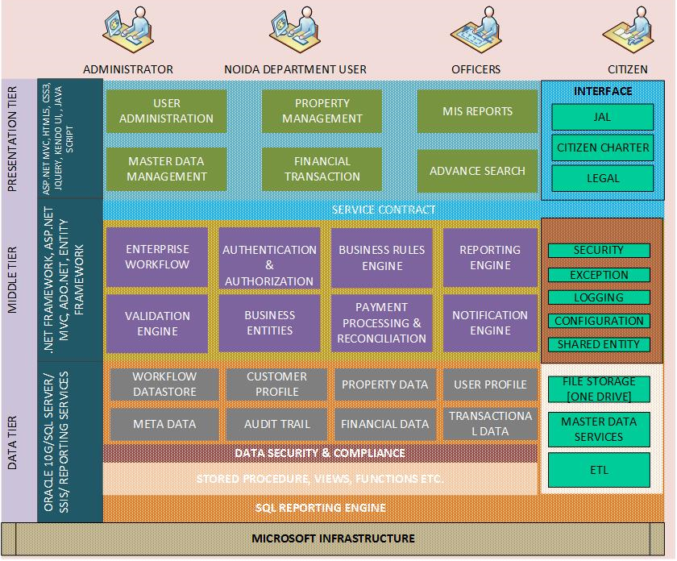

Diagram 1 – Overall Architecture of NOIDA System

Presentation Layer:
This is the topmost level of the application. It communicates with other tiers by outputting results to the browser/client tier from all other tiers in the system and providing a platform for input details sort for by them. This layer contains the user oriented functionality responsible for managing user interaction with the system, and generally consists of components that provide a common bridge into the core business logic encapsulated in the business layer.
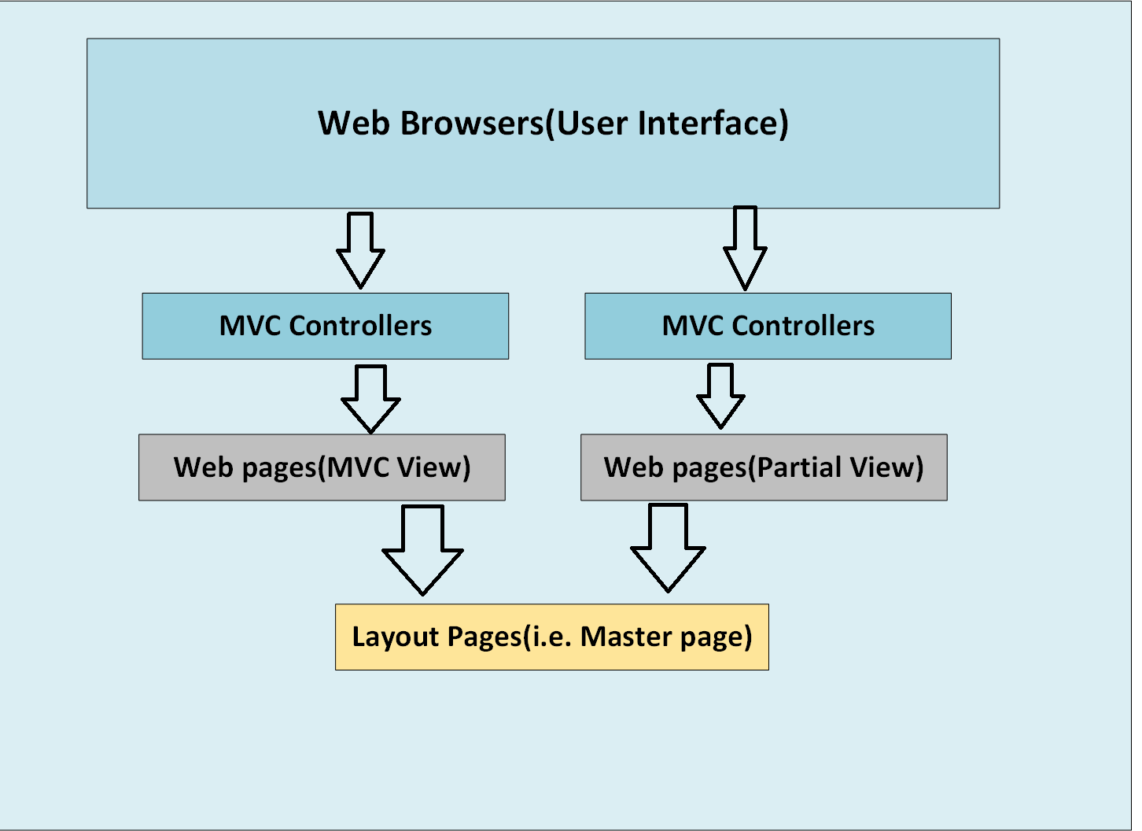
Diagram 2 – Presentation Layer
The presentation layer will usually include the following:
- User Interface components. These are the application's visual elements used to display information to the user and accept user input.
- Presentation Logic components. Presentation logic is the application code that defines the logical behavior and structure of the application in a way that is independent of any specific user interface implementation.
This layer also covers the following aspects of our application:
- Authentication and Authorization
- URL Routing
- Caching
- Navigation & Redirection
- User Experience & Interface
- Validation

Service Layer:
To support scalability and future expansion so that our application can provide services to other applications, a services layer that exposes the business functionality of the application has been added to the application’s architecture.
The services layer effectively provides an alternative view that allows clients to use a different channel to access the application. Internally, each service is made up of software components, just like any other application, and these components can be logically grouped into presentation, business, and data layers. Other applications can make use of the services without being aware of the way they are implemented.
This layer implements the core functionality of the system, and encapsulates the relevant business logic. It generally consists of components, some of which may expose service interfaces that other callers can use. The logic tier is pulled out from the presentation tier and, as its own layer; it controls an application’s functionality by performing detailed processing.
The business layer includes the following:
- Application façade. This optional component typically provides a simplified interface to the business logic components, often by combining multiple business operations into a single operation that makes it easier to use the business logic. It reduces dependencies because external callers do not need to know details of the business components and the relationships between them.
- Business Logic components. Business logic is defined as any application logic that is concerned with the retrieval, processing, transformation, and management of application data; application of business rules and policies; and ensuring data consistency and validity. To maximize reuse opportunities, business logic components should not contain any behavior or application logic that is specific to a use case or user story. After the UI components collect the required data from the user and pass it to the business layer, the application can use this data to perform a business process. Business processes involve multiple steps that must be performed in the correct order, and may interact with each other through an orchestration. Business workflow components define and coordinate long running, multistep business processes, and can be implemented using business process management tools.

Repository Layer:
Business entities, or—more generally—business objects, encapsulate the business logic and data necessary to represent real world elements, within your application. They need the data values and expose them through properties; contain and manage data used by the application; and provide statefull programmatic access to the data and related functionality.
Repository layer consist of such elements that provides the access to database through ORM frameworks such as Entity framework and its data models.
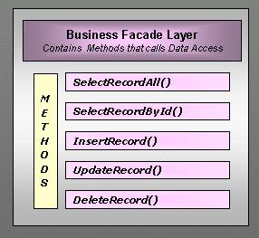
Diagram 3 – Repository Layer

This layer also covers the following aspects of our application:
- Caching
- Coupling and Cohesion
- Validation

Data Layer:
This layer provides access to data hosted within the boundaries of the system, and data exposed by other networked systems; perhaps accessed through services. The data layer exposes generic interfaces that the components in the Repository layer can consume. So it has been achieved by putting a ORM from Microsoft technologies known as Entity Framework.
The data layer may include the following:
- Data Access components. These components abstract the logic required to access the underlying data stores. They centralize common data access functionality in order to make the application easier to configure and maintain. Some data access frameworks may require the developer to identify and implement common data access logic in separate reusable helper or utility data access components. Other data access frameworks, including many Object/Relational Mapping (O/RM) frameworks, implement such components automatically, reducing the amount of data access code that the developer must write.
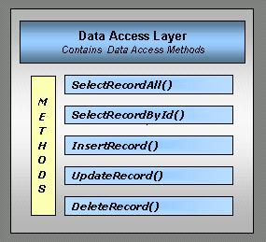
Diagram 4 – Data Access Layer
This layer also covers the following aspects of our application:
- Connections
- Data Format
- Object Relational Mapping
- Queries
- Stored Procedures & Dynamic SQL
- Transactions

Low Level System Design

Authentication and Authorization
This module deals with the security and access authority to accomplish the set of functions that the users are authorized to perform.
Authorization: The purpose of authorization is to determine whether an identity should be granted the requested type of access to a given resource.
Authentication: Authentication is the process of discovering and verifying the identity of a principal, by examining the user's credentials and validating those credentials against some authority. The information obtained during authentication is directly usable by your code. That is, once the identity of the user is discovered, we then use .NET Framework’s role-based security to determine whether to allow that user/request to access the functionality sort for.
Role based: Users are partitioned into application-defined, logical roles. Members of a particular role share the same privileges within the application. Access to operations (typically expressed by method calls) is authorized based on the role-membership of the caller.
Resources are accessed using fixed identities (such as a Web application's or Web service's process identity). The resource managers trust the application to correctly authorize users and they authorize the trusted identity.

Login/Logout Process:
This feature will be used by Users of the System to login and perform their designated tasks following authentication checks. The User will be able to logout of the System on clicking logout feature.

Use Case Model

ALL USERS
Login

Logout

Administrator
Forgot Password

Diagram 5 – Login/Logout Process Use Case Diagram

User Login and forgot password Sequence Diagram:
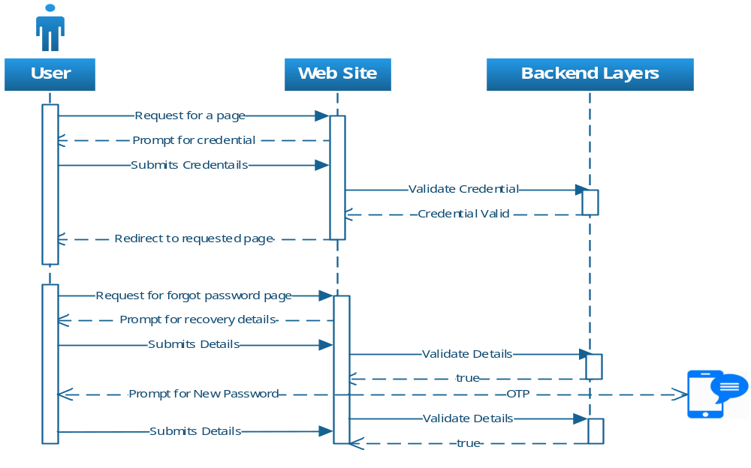
The above flow depicts the request to login a user to the system via the login screen, by passing the User ID and Password as parameters. Post successful login the user is automatically redirected to the home/default page of the application.
In case of password recovery user will be redirect to generate an OTP which will be sent to user cell phone. Later user can change password using that OTP.

Method Details:
Method Name | Return Type | Parameters | Description
LogIn | bool | UserName, password | Validate the username and password for the membership user.
GetOTPassword | String | UserId, emailId, MobNo | Gets the OT password for the membership user from the membership data store.
ForgotPassword | bool | OTP | Validate the one time password for the membership user.
ResetPassword | Bool | oldPassword, newPassword | Resets a user's password to a new, automatically generated password.

User Management By Super Administrator:
This system allows to perform multi-tenant user management. A super administrator can privilege more than one administrator to add, edit activate, deactivate, lock and delete users. The super administrator can perform all the activities that other administrator can do.
Users can be added to the system here. It allows for entering user name, contact details, and user level. The user level determines the level of access and authority a user has privilege to.

Use Case Model
Create Admin
Edit Admin
Delete Admin
View Admin
Activate Admin
Deactivate Admin
Map Users
Super
Add Users
Administrator
Edit Users
View Users
Deactivate Role Level
Deactivate User
lock User
Diagram 6– Admin Management Use Case Diagram

Web/Presentation Layer
Method Name | Return Type | Parameters | Description
AddAdminRole | bool | IEnumerable<AdminRoleAttributes> | Create new Admin role in the system
DeleteAdminRole | bool | adminRoleId | Delete admin role from system
UpdateAdminRole | bool | IEnumerable<AdminRoleAttributes> | Update the AdminRole details
GetAdminRole | IEnumerable<AdminRoleParameters> | adminRoleId | Get details of a Admin role
IsAdminExists | bool | adminRoleId | Check if the Admin with same name is already exists
ActivateAdminRole | bool | adminRoleId | Activate the given Admin
DeActivateAdminRole | bool | adminRoleId | DeActivate the given Admin
AddUser | bool | IEnumerable<UserLevelAttributes> | Add a user to the system
UpdateUser | bool | IEnumerable<UserLevelAttributes> | Update user details in the system
DeleteUser | bool | userId | Delete a user from the system
GetUser | IEnumerable<UserLevelAttributes> | userId | Get all the details of a User
LockUnlockUser | Bool | Bool(True/False) | Lock/Unlock user in the system

Business and Repository Layer

Method Details:
Method Name | Return Type | Parameters | Description
AddAdminRole | bool | IEnumerable<AdminRoleAttributes> | Create new Admin role in the system
DeleteAdminRole | bool | adminRoleId | Delete admin role from system
UpdateAdminRole | bool | IEnumerable<AdminRoleAttributes> | Update the AdminRole details
GetAdminRole | IEnumerable<AdminRoleParameters> | adminRoleId | Get details of a Admin role
IsAdminExists | bool | adminRoleId | Check if the Admin with same name is already exists
ActivateAdminRole | bool | adminRoleId | Activate the given Admin
DeActivateAdminRole | bool | adminRoleId | DeActivate the given Admin
AddUser | bool | IEnumerable<UserLevelAttributes> | Add a user to the system
UpdateUser | bool | IEnumerable<UserLevelAttributes> | Update user details in the system
DeleteUser | bool | userId | Delete a user from the system
GetUser | IEnumerable<UserLevelAttributes> | userId | Get all the details of a User
LockUnlockUser | Bool | Bool(True/False) | Lock/Unlock user in the system

Sequence Diagram

Admin Role Management Sequence Diagram:
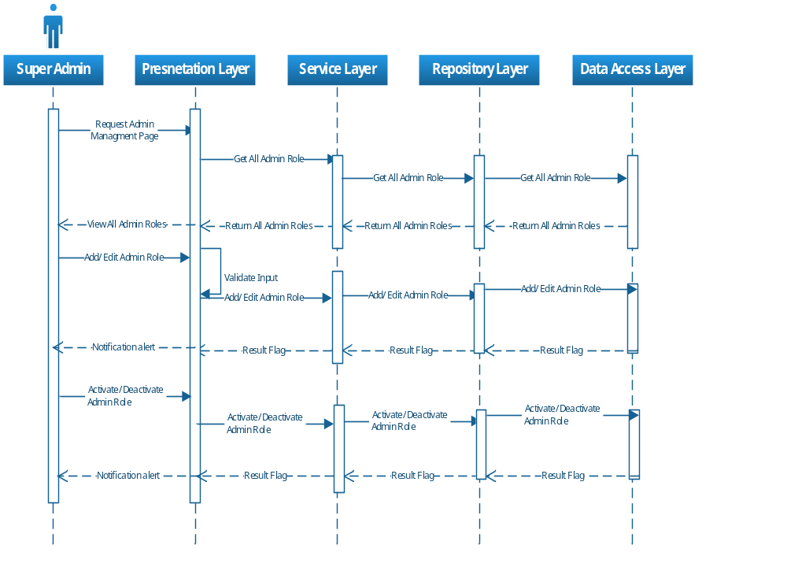

Diagram 7 – Admin Role Management Sequence Diagram
The above flow depicts the process to create, update, delete and get Admin roles for the application. Roles in the application would be logical segregations used to distinguish the access rights to the different users of the application.

User Management Sequence Diagram (Super admin):

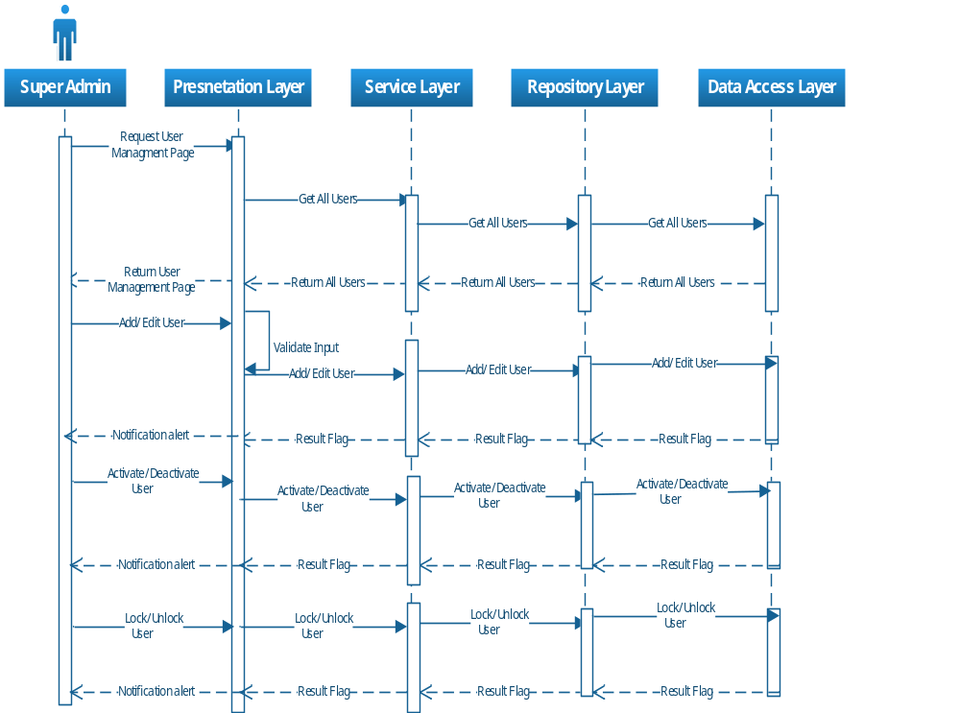
Diagram 8 –User Management Sequence Diagram
The above flow depicts the process to create, update, delete and get Admin users for the application. Users in the application would be logical segregations used to distinguish the access rights to the different users of the application.

User Management By Administrator:

Edit User
Delete user
View User
Activate User
Deactivate User
View User Role
Add User Role
Administrator
Edit User Role
Maps Users
Deactivate User Role
Revoke User

Diagram 9 – User Management Use Case Diagram
Method Details:
Method Name | Return Type | Parameters | Description
AddUser | bool | IEnumerable<UserLevelAttributes> | Add a user to the system
UpdateUser | bool | IEnumerable<UserLevelAttributes> | Update user details in the system
DeleteUser | bool | userId | Delete a user from the system
GetUser | IEnumerable<UserLevelAttributes> | userId | Get all the details of a User
GetAllUser | IEnumerable<UserLevelAttributes> | UserStatus (active , inactive , all) | Get all Users
ActivateUser | bool | userId | Activate the user in the system
DeactivateUser | bool | userId | Deactivate the user
AddRole | bool | IEnumerable<RoleLevelAttributes> | Create a new role in the system
UpdateRole | bool | IEnumerable<RoleLevelAttributes> | Update role details
DeleteRole | bool | roleId | Delete a role from the system
GetRole | IEnumerable<RoleLevelAttributes> | roleId | Get the details of a Role
GetAllRoles | IEnumerable<UserLevelAttributes> | Rolestate (active , inactive , all) | Get list of all roles available in system
IsRoleExists | bool | roleName | Check if the role with same name is already present
ActivateRole | bool | roleId | Activate the given role
DeActivateRole | bool | roleId | DeActivate the given role
GetAllUsersForRole | List<string> | roleId | Get all users present for a role
RevokeUser | List<UserAttributes> | userId | Revoke user rights

Business Layer
Method Details:
Method Name | Return Type | Parameters | Description
AddUser | bool | IEnumerable<UserLevelAttributes> | Add a user to the system
UpdateUser | bool | IEnumerable<UserLevelAttributes> | Update user details in the system
DeleteUser | bool | userId | Delete a user from the system
GetUser | IEnumerable<UserLevelAttributes> | userId | Get all the details of a User
ActivateUser | bool | userId | Activate the user in the system
DeactivateUser | bool | userId | Deactivate the user
AddRole | bool | IEnumerable<RoleLevelAttributes> | Create a new role in the system
UpdateRole | bool | IEnumerable<RoleLevelAttributes> | Update role details
DeleteRole | bool | roleId | Delete a role from the system
GetRole | IEnumerable<RoleLevelAttributes> | roleId | Get the details of a Role
GetAllRoles | IEnumerable<UserLevelAttributes> | Rolestate (active , inactive , all) | Get list of all roles available in system
IsRoleExists | bool | roleName | Check if the role with same name is already present
ActivateRole | bool | roleId | Activate the given role
DeActivateRole | bool | roleId | DeActivate the given role
GetAllUsersForRole | List<string> | roleId | Get all users present for a role
RevokeUser | Bool | userId | Revoke a user

Role Management Sequence Diagram (Admin):
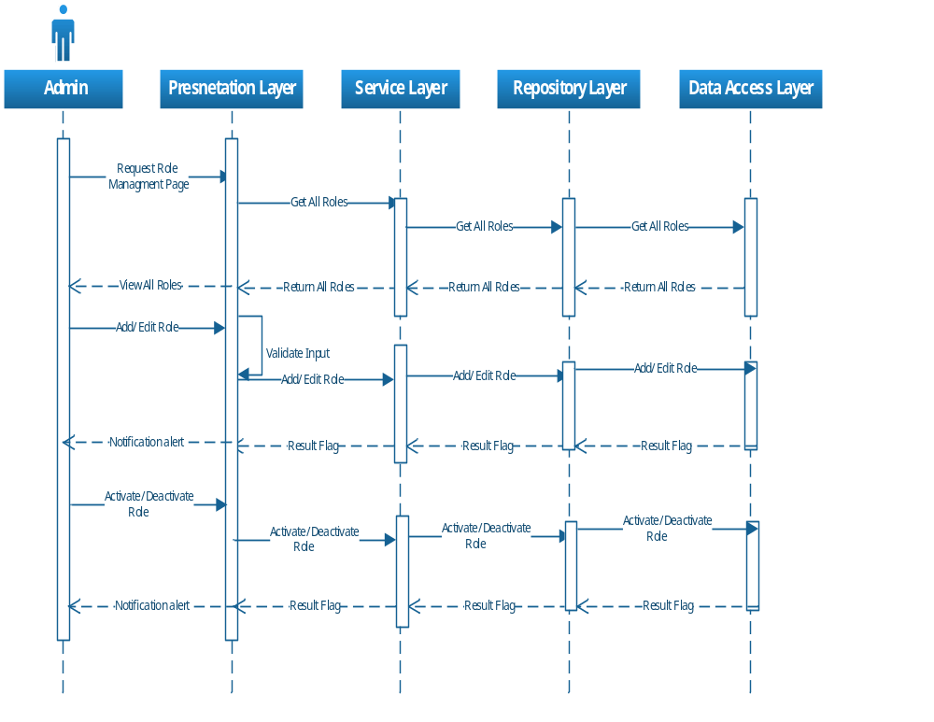
Diagram 10 – Role Management Sequence Diagram
The above flow depicts the process to create, update and delete roles for the application.

Map User Sequence Diagram (Admin):

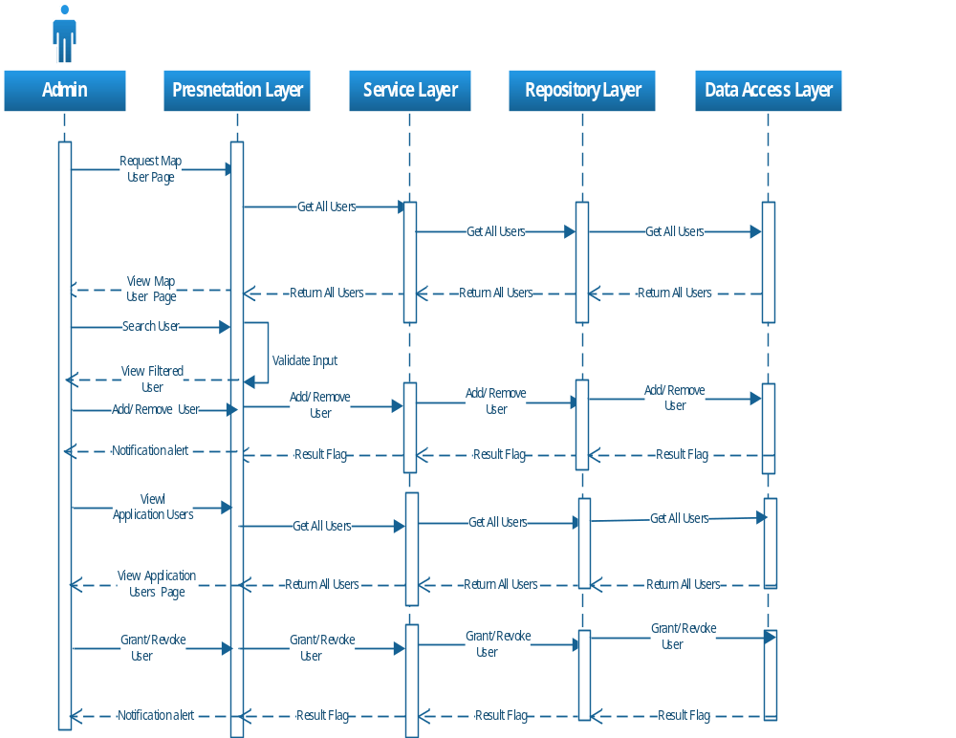

Diagram 11 – User Management Sequence Diagram

Menu Mapping
This feature allows the Admin to map the accesses to each User level. This will determine which menu and submenu options are available to the users.
Method Details:
Method Name | Return Type | Parameters | Description
GetAllMenus | IEnumerable<MenuSecurityAttributes> |  | Get the list of all the top level menus available in the system
GetAllRoleByAdmin | IEnumerable<roleAttribute> | AdminId | Get the list of all the roles of the given Admin id
SetMenuSecurityForRole | bool | menuSecurityAttributes,  RoleIDList,  AdminId | Save all menu details for the given AdminId

Business Layer
Method Details:
Method Name | Return Type | Parameters | Description
GetAllMenus | IEnumerable<MenuSecurityAttributes> |  | Get the list of all the top level menus available in the system
GetAllRoleByAdmin | IEnumerable<roleAttribute> | AdminId | Get the list of all the roles of the given Admin id
SetMenuSecurityForRole | bool | menuSecurityAttributes,  RoleIDList,  AdminId | Save all menu details for the given AdminId

Sequence Diagram

Menu Security Sequence Diagram:
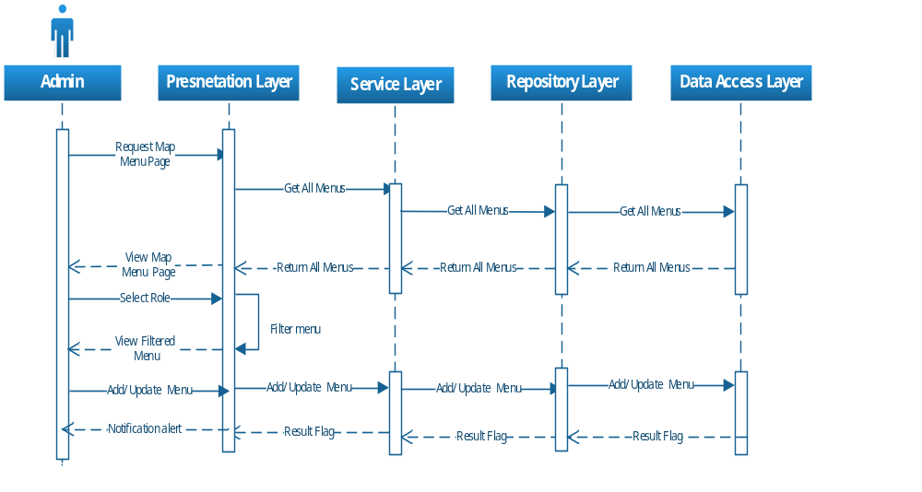

Diagram 12 – Menu Security/Mapping Sequence Diagram
The above flow depicts the process to set and update menu level security for the application based on the user roles. Each role will have the ability to restrict and provide the access to its members for accessing/using pages, features and methods based upon selection while menu mapping.

Master Data management
Admin can manage schema, projects, notification and refund. A new schema need to be created as a master data element before creating properties, notifications and refunds.

Manage Scheme
Admin can create, edit, remove and view schema.
Method Details:
Method Name | Return Type | Parameters | Description
AddScheme | bool | IEnumerable<SchemeLevelAttributes> | Add a Scheme to the system
UpdateScheme | bool | IEnumerable<SchemeLevelAttributes> | Update Scheme details in the system
RemoveScheme | bool | SchemeId | Delete a Scheme from the system
GetScheme | IEnumerable<SchemeLevelAttributes> | SchemeId | Get all the details of a Scheme
GetAllScheme | IEnumerable<SchemeLevelAttributes> | SchemeStatus (active , inactive , all) | Get all Schemes
UndoRemove | bool | SchemeId | Undo removed Scheme in the system

Business Layer
Method Details:
Method Name | Return Type | Parameters | Description
AddScheme | bool | IEnumerable<SchemeLevelAttributes> | Add a Scheme to the system
UpdateScheme | bool | IEnumerable<SchemeLevelAttributes> | Update Scheme details in the system
RemoveScheme | bool | SchemeId | Delete a Scheme from the system
GetScheme | IEnumerable<SchemeLevelAttributes> | SchemeId | Get all the details of a Scheme
GetAllScheme | IEnumerable<SchemeLevelAttributes> | SchemeStatus (active , inactive , all) | Get all Schemes
UndoRemove | bool | SchemeId | Undo removed Scheme in the system

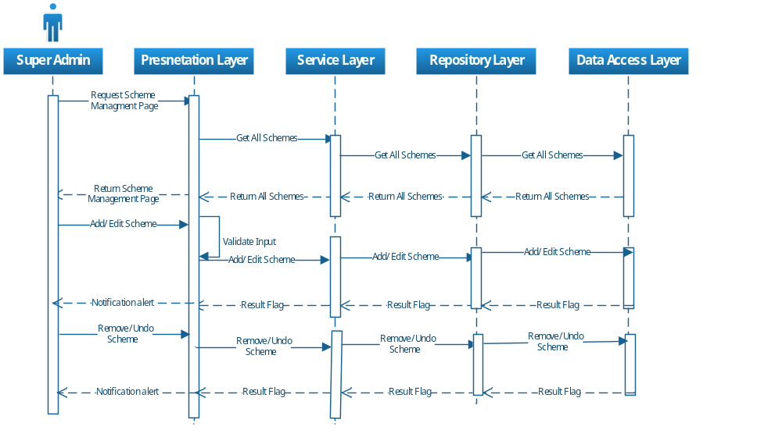
Diagram 13 – Manage Scheme Sequence Diagram

Manage Property
Admin can create a project with any scheme available. All other CURD operations for project can be done.
Method Details:
Method Name | Return Type | Parameters | Description
AddProperty | bool | IEnumerable<PropertyLevelAttributes> | Add a Property to the system
UpdateProperty | bool | IEnumerable<PropertyLevelAttributes> | Update Property details in the system
RemoveProperty | bool | PropertyId | Delete a Property from the system
GetProperty | IEnumerable<PropertyLevelAttributes> | PropertyId | Get all the details of a Property
GetAllProperties | IEnumerable<PropertyLevelAttributes> | PropertyStatus (active , inactive , all) | Get all Properties

Business Layer
Method Details:
Method Name | Return Type | Parameters | Description
AddProperty | bool | IEnumerable<PropertyLevelAttributes> | Add a Property to the system
UpdateProperty | bool | IEnumerable<PropertyLevelAttributes> | Update Property details in the system
RemoveProperty | bool | PropertyId | Delete a Property from the system
GetProperty | IEnumerable<PropertyLevelAttributes> | PropertyId | Get all the details of a Property
GetAllProperties | IEnumerable<PropertyLevelAttributes> | PropertyStatus (active , inactive , all) | Get all Properties with schema

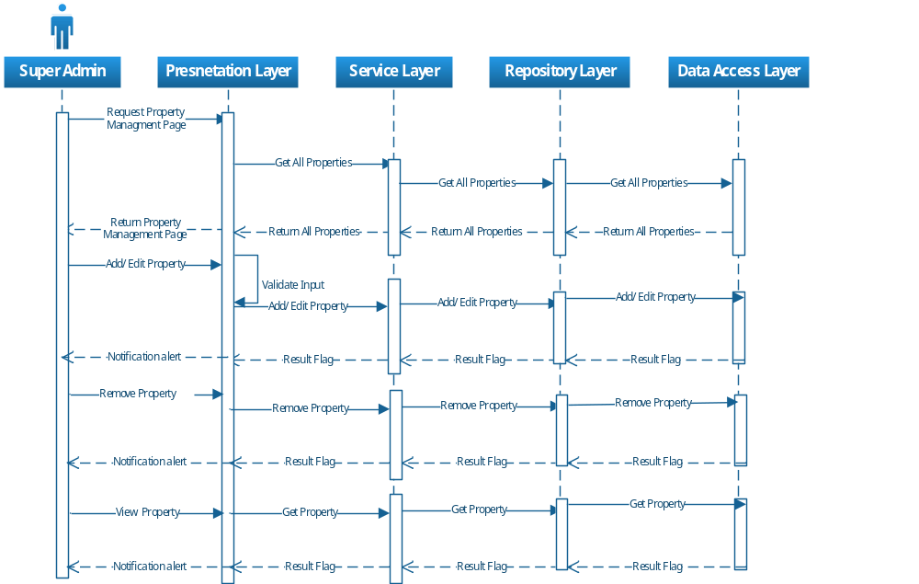
Diagram 14 – Manage Property Sequence Diagram

Manage Notification
Admin can create a notification with any scheme available. All other CURD operations for notification can be done.

Method Details:
Method Name | Return Type | Parameters | Description
AddNotification | bool | IEnumerable<NotificationLevelAttributes> | Add a Notification to the system
UpdateNotification | bool | IEnumerable<NotificationLevelAttributes> | Update Notification details in the system
RemoveNotification | bool | NotificationId | Delete a Notification from the system
GetNotification | IEnumerable<NotificationLevelAttributes> | NotificationId | Get all the details of a Notification
GetAllNotifications | IEnumerable<NotificationLevelAttributes> | NotificationStatus (active , inactive , all) | Get all Notifications

Business Layer
Method Details:
Method Name | Return Type | Parameters | Description
AddNotification | bool | IEnumerable<NotificationLevelAttributes> | Add a Notification to the system
UpdateNotification | bool | IEnumerable<NotificationLevelAttributes> | Update Notification details in the system
RemoveNotification | bool | NotificationId | Delete a Notification from the system
GetNotification | IEnumerable<NotificationLevelAttributes> | PropertyId | Get all the details of a Notification
GetAllNotifications | IEnumerable<NotificationLevelAttributes> | NotificationStatus (active , inactive , all) | Get all Notifications

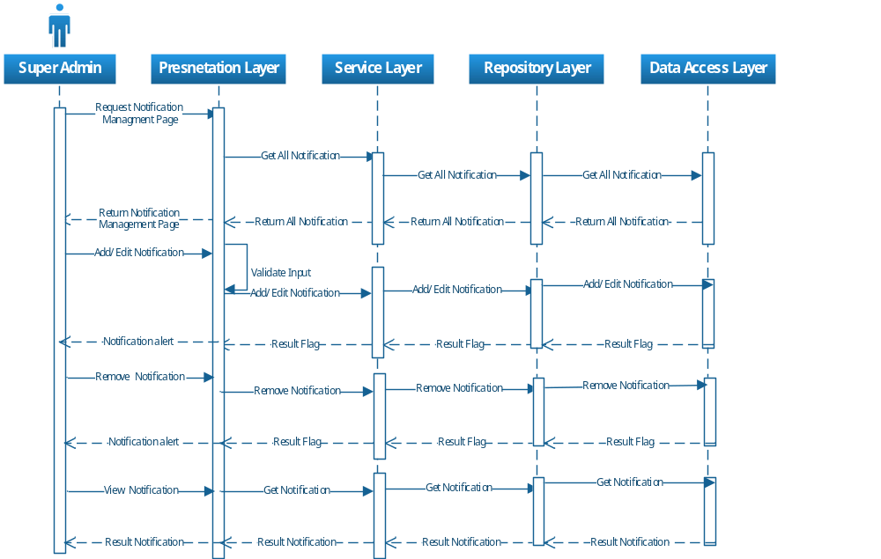
Diagram 15 – Manage Notification Sequence Diagram

Manage Refund
Admin can create a refund with any scheme available. All other CURD operations for refund can be done.

Method Details:
Method Name | Return Type | Parameters | Description
AddRefund | bool | IEnumerable<RefundLevelAttributes> | Add a Refund to the system
UpdateRefund | bool | IEnumerable<RefundLevelAttributes> | Update Refund details in the system
RemoveRefund | bool | RefundId | Delete a Refund from the system
GetRefund | IEnumerable<RefundLevelAttributes> | RefundId | Get all the details of a Refund
GetAllRefunds | IEnumerable<RefundLevelAttributes> | RefundStatus (active , inactive , all) | Get all Refunds

Business Layer
Method Details:
Method Name | Return Type | Parameters | Description
AddRefund | bool | IEnumerable<RefundLevelAttributes> | Add a Refund to the system
UpdateRefund | bool | IEnumerable<RefundLevelAttributes> | Update Refund details in the system
RemoveRefund | bool | RefundId | Delete a Refund from the system
GetRefund | IEnumerable<RefundLevelAttributes> | RefundId | Get all the details of a Refund
GetAllRefunds | IEnumerable<RefundLevelAttributes> | RefundStatus (active , inactive , all) | Get all Refunds

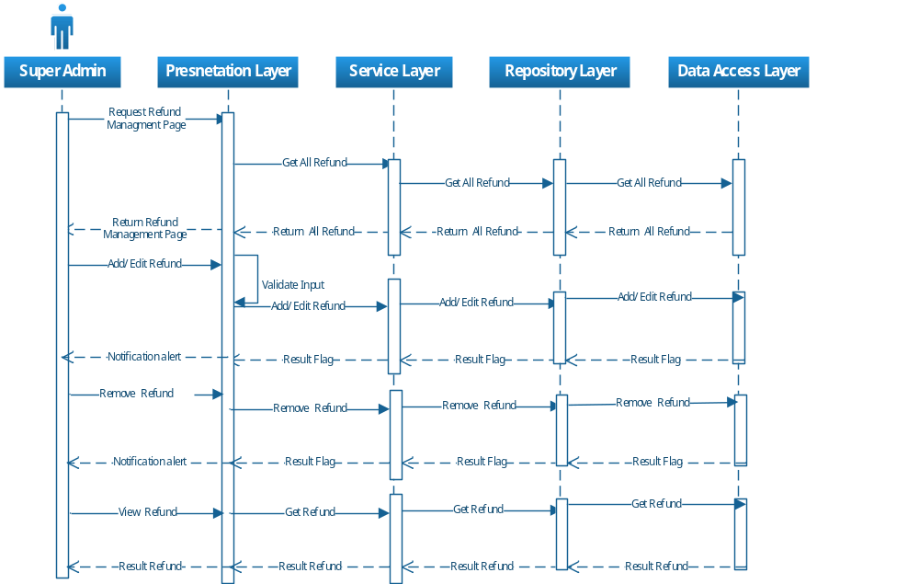
Diagram 16 – Manage Refund Sequence Diagram

Master Allotment process
Admin can manage applications for allotment process. A new application need to be created as an initial step in this process before creating allotment process. Approval, rejection and refunds can be processed further as required.

Manage Applications
Admin can create, edit, remove and view application.
Method Details:
Method Name | Return Type | Parameters | Description
AddApplication | bool | ApplicationAttribute | Add an Application to the system
UpdateApplication | bool | ApplicationAttribute | Update Application details in the system
GetApplication | ApplicationAttribute | ApplicationId | Get all the details of an Application
GetAllApplications | IEnumerable<Application Attributes> | Application Status (active , inactive , all) | Get all Applications
BulkLoadApplications | bool | IEnumerable<ApplicationAttributes> | Save all Applications

Business Layer
Method Details:
Method Name | Return Type | Parameters | Description
AddApplication | bool | ApplicationAttribute | Add an Application to the system
UpdateApplication | bool | ApplicationAttribute | Update Application details in the system
GetApplication | ApplicationAttribute | ApplicationId | Get all the details of an Application
GetAllApplication | IEnumerable<Application Attributes> | Application Status (active , inactive , all) | Get all Applications
BulkLoadApplications | bool | IEnumerable<ApplicationAttributes> | Save all Applications
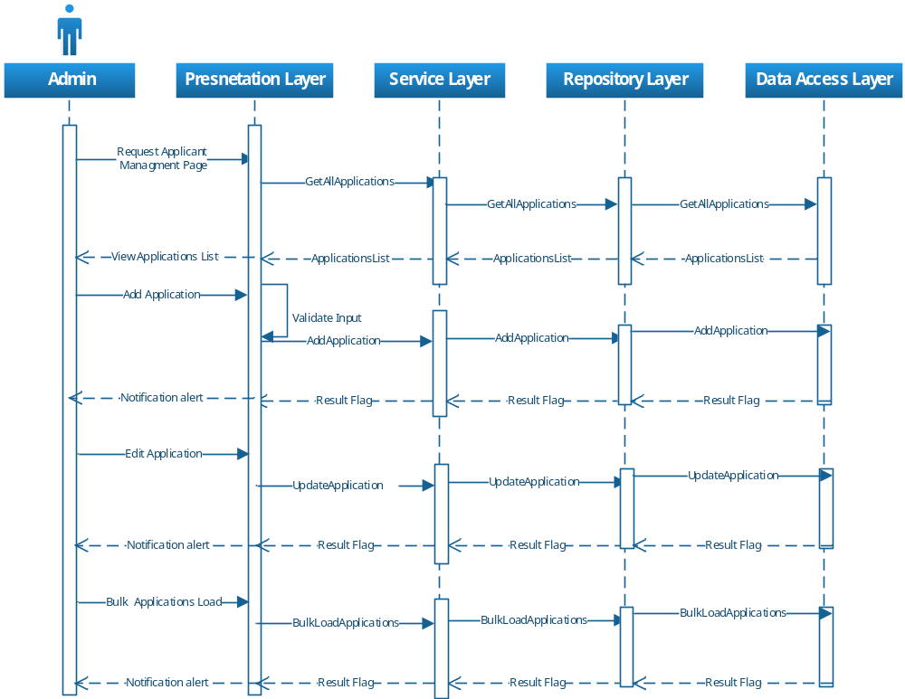

Diagram 17 – Manage Applicant Sequence Diagram

Manage Allotments
Admin can create, edit, remove and view Allotments.
Method Details:
Method Name | Return Type | Parameters | Description
AddAllotment | bool | Allotment Attribute | Add an Allotment to the system
UpdateAllotment | bool | Allotment Attribute | Update Allotment details in the system
GetAllotment | Allotment Attribute | AllotmentId | Get all the details of an Allotment
GetAllAllotment s | IEnumerable<Allotment Attributes> | Allotment Status (active , inactive , all) | Get all Allotments
BulkLoadAllotments | bool | IEnumerable<AllotmentAttributes> | Save all Allotments

Business Layer
Method Details:
Method Name | Return Type | Parameters | Description
AddAllotment | bool | AllotmentAttribute | Add an Allotment to the system
UpdateAllotment | bool | AllotmentAttribute | Update Allotment details in the system
GetAllotment | AllotmentAttribute | AllotmentId | Get all the details of an Allotment
GetAllAllotment | IEnumerable<Allotment Attributes> | Allotment Status (active , inactive , all) | Get all Allotments
BulkLoadAllotments | bool | IEnumerable<AllotmentAttributes> | Save all Allotments

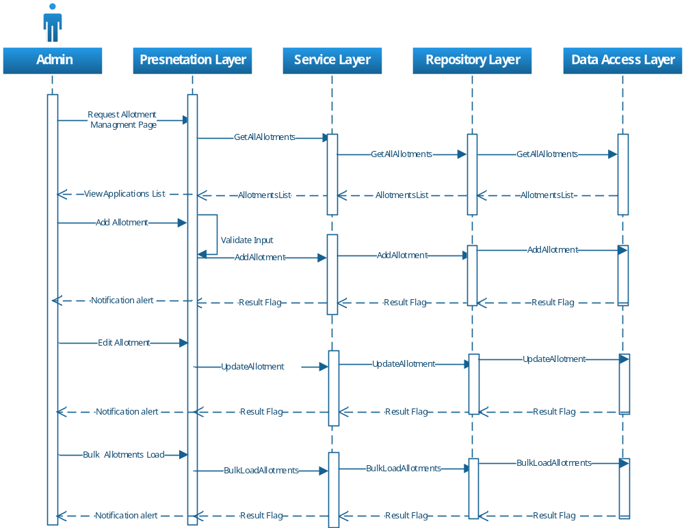
Diagram 18 – Manage Allotment Sequence Diagram

Manage Allottee List of a scheme
Allottee list would be created by system based on allotment entry. Allottee list should be visible department wise for each scheme, user can only see entries for his departments
Method Details:
Method Name | Return Type | Parameters | Description
GetAllotteelist | IEnumerable<Allotteelist Attributes> | SchemeId | Get all the details of Allotteelist for a specific scheme
SubmitAllotteelist | bool | IEnumerable<Allotteelist Attributes> | Submit all Allotteelists
GetComments | Comment Attribute | SchemeId | Get all the details of comments

Business Layer
Method Details:
Method Name | Return Type | Parameters | Description
GetAllotteelist | IEnumerable<Allotteelist Attributes> | SchemeId | Get all the details of Allotteelist for a specific scheme
SubmitAllotteelist | bool | IEnumerable<Allotteelist Attributes> | Submit all Allotteelists
GetComments | Comment Attribute | SchemeId | Get all the details of comments

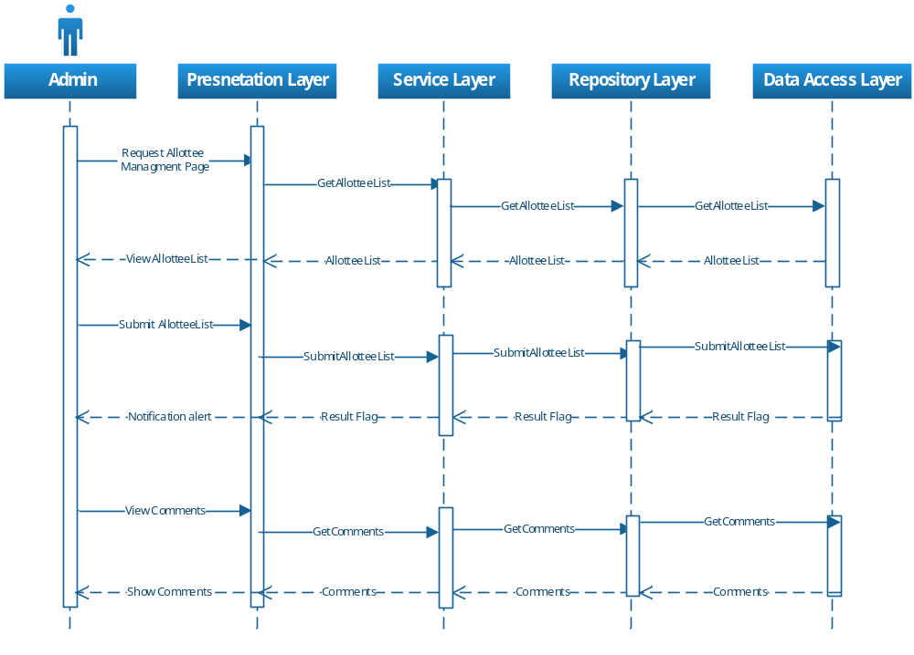
Diagram 19 – Manage Allottee Sequence Diagram

Manage Refund
Unsuccessful Allottee list would be created by system based on allotment entry. These allottee list should be visible department wise for each scheme, user can only see entries for his departments
Method Details:
Method Name | Return Type | Parameters | Description
GetFailedAllotteelist | IEnumerable<Allotteelist Attributes> | SchemeId | Get all the details of failed Allotteelist for a specific scheme
SubmitRefundAllotteelist | bool | IEnumerable<Allotteelist Attributes> | Submit all Allotteelists for refund
GetRefundComments | Comment Attribute | SchemeId | Get all the details of comments

Business Layer
Method Details:
Method Name | Return Type | Parameters | Description
GetFailedAllotteelist | IEnumerable<Allotteelist Attributes> | SchemeId | Get all the details of failed Allotteelist for a specific scheme
SubmitRefundAllotteelist | bool | IEnumerable<Allotteelist Attributes> | Submit all Allotteelists for refund
GetRefundComments | Comment Attribute | SchemeId | Get all the details of comments

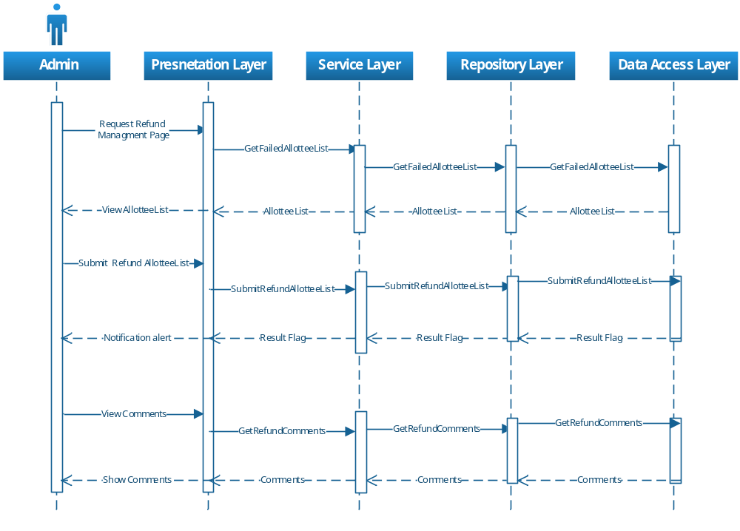
Diagram 20 – Manage Refund Sequence Diagram

Manage Request
Successful Allottee list would be created by system based on allotment entry. These allottee list should be visible department wise for each scheme, user can only see entries for his departments
Method Details:
Method Name | Return Type | Parameters | Description
GetSuccAllotteelist | IEnumerable<Allotteelist Attributes> | SchemeId | Get all the details of Success Allotteelist for a specific scheme
ApproveRejectAllotteelist | bool | IEnumerable<Allotteelist Attributes> | Submit all Allotteelists for Aprrove or Reject process
GetComments | Comment Attribute | SchemeId | Get all the details of comments

Business Layer
Method Details:
Method Name | Return Type | Parameters | Description
GetSuccAllotteelist | IEnumerable<Allotteelist Attributes> | SchemeId | Get all the details of Success Allotteelist for a specific scheme
ApproveRejectAllotteelist | bool | IEnumerable<Allotteelist Attributes> | Submit all Allotteelists for Aprrove or Reject process
GetComments | Comment Attribute | SchemeId | Get all the details of comments

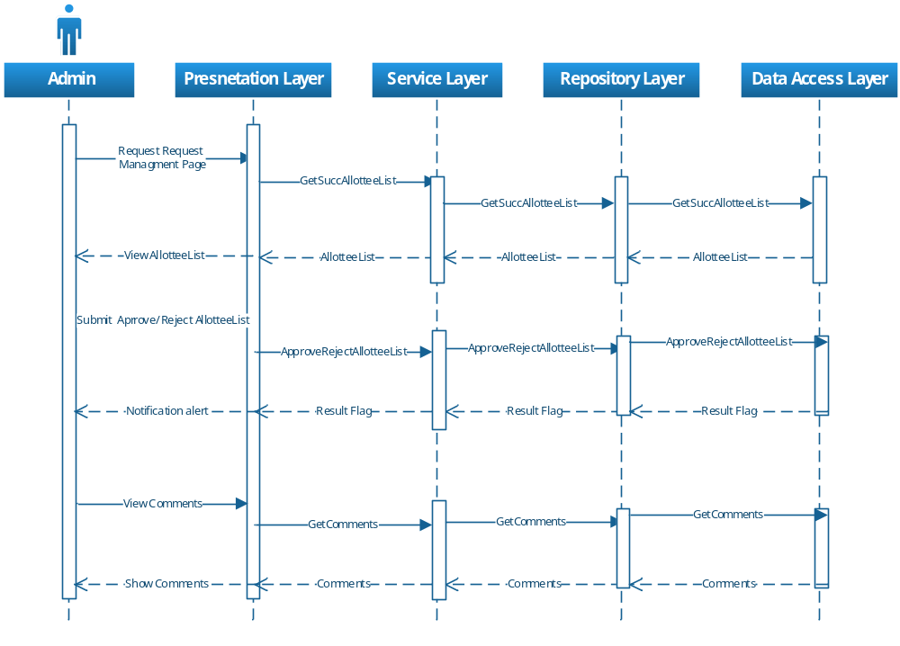
Diagram 21 – Manage Request Sequence Diagram

Database Design

User Management

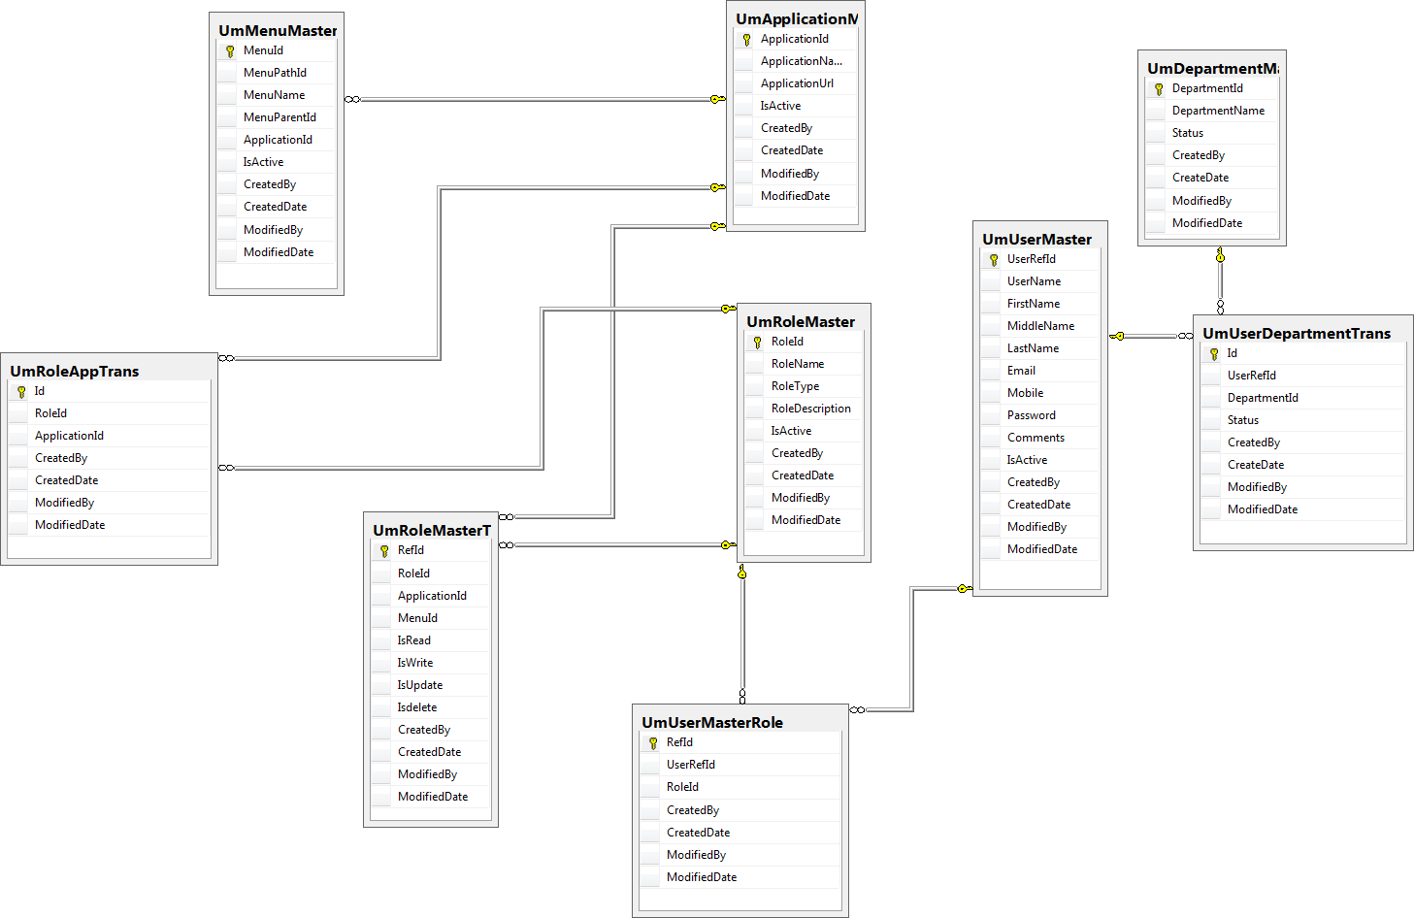

Meta data Management
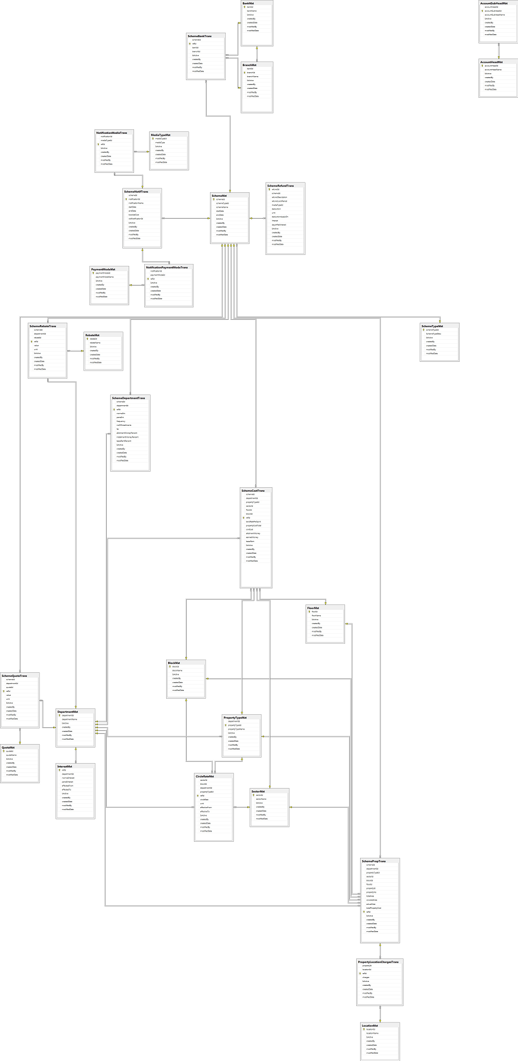

6. Appendix

